**Day 1 Lab Assignments**

1. Make simple CV with skill bars indicating your skills, as the following (Just make the main items and layout)

**(use new HTML5 structural elements in layout):**

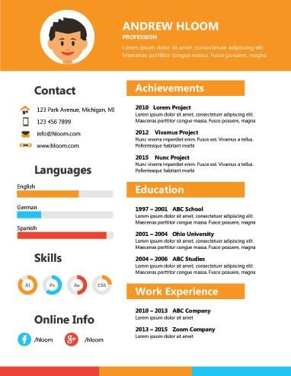

* 1. Use Time tag to display your birthdate in your CV.
  2. Try to make your page is responsive in any screen size (Use viewport meta tag and use relative sizing).

1. In assignment No.1, Use hidden audio element (without controls), that plays ringing sound when mouse is over contact section, and stop it when the mouse is away (You can search for a sound here: <https://www.soundsnap.com/search/audio> ).
2. In Assignment No.1, use video element to display a video about you in your page.
3. Make a page that has a button that when clicked gets your location and show it on google maps on a new window (Use HTML5 GeoLocation).
4. Use HTML5 drag and drop, to make the following assignment:

Make a div with width and height: 100px, and make a border and background color for it, and make an image that can be dragged and dropped on the div.

* 1. Make 3 images and make the div allowing drop of specific image only.
  2. Change the div background when the image is dropped over it.

**Bonus Assignments:**

1. Refer to the following links for Meter tag styling and tricks:   
   <https://css-tricks.com/html5-meter-element/>   
   <https://www.hongkiat.com/blog/style-html5-meter/>
2. Design a home page for yourself using HTML5 structural elements, and use the following layout:

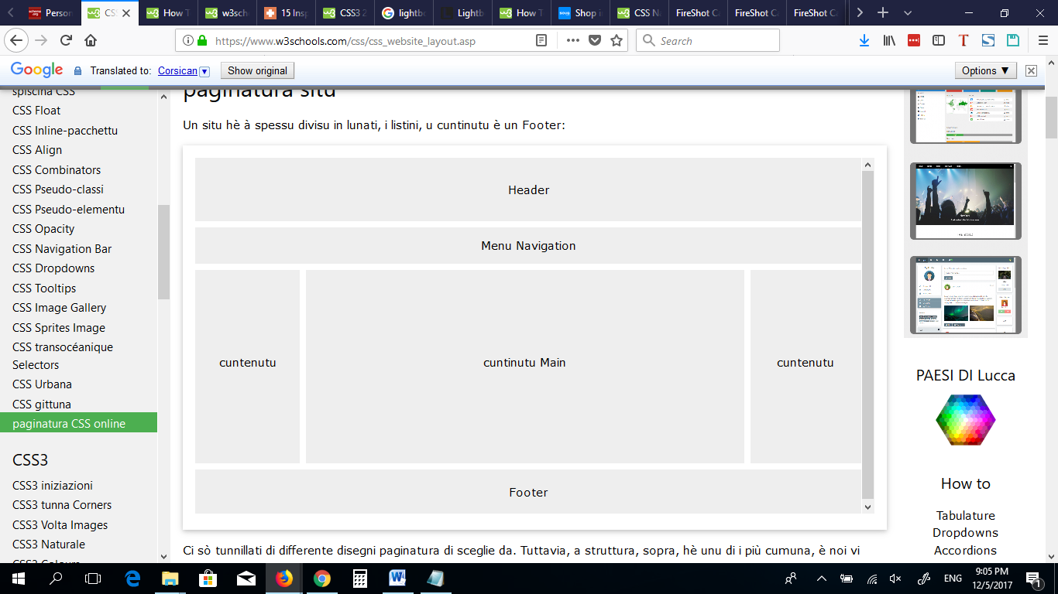

1. In previous Assignment, use MicroData with your personal info in your CV, and use Google Structured Data Testing Tool: (<http://www.google.com/webmasters/tools/richsnippets>) to test it.
2. Search for the following HTML5 new features, and make a demo on them:
   1. HTML5 App Cache
   2. HTML5 Web Workers
   3. HTML5 Drag&Drop
   4. HTML5 Server Sent Events.
   5. HTML5 Fallback and Polyfills
   6. Html5 Script Loader
3. Search for HTML 5, 6 new features
4. Innovate in your CV and add other attractive content to it.
5. In the given tiger Demo, paly a sound when the tiger arrives to the end of the page.
6. Search for HTML5 new tags and use it and use it.
7. Search for CSS3 new features and use it.

**<Thank>YOU </Thank>**